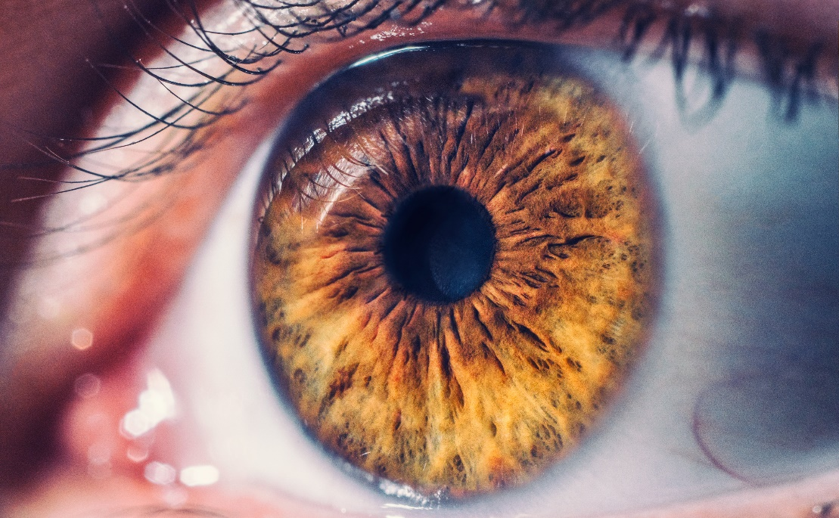

Diabetic Retinopathy Detection

Zed Al Aas | CAPSTONE PROJECT | 04/12/2021

# Introduction

Diabetic retinopathy is a complication of diabetes and a leading cause of blindness. It occurs when diabetes damages the tiny blood vessels inside the retina, the light-sensitive tissue at the back of the eye. A healthy retina is necessary for good vision.

All people with diabetes—both type 1 and type 2—are at risk. That's why everyone with diabetes should get a comprehensive dilated eye exam at least once a year. Between 40 to 45 percent of Americans diagnosed with diabetes have some stage of diabetic retinopathy.

During pregnancy, diabetic retinopathy may be a problem for women with diabetes. To protect vision, every pregnant woman with diabetes should have a comprehensive dilated eye exam as soon as possible.

Diabetic Retinopathy Levels are:

* Class 0: Negative diabetic retinopathy
* Class 1: Mild non-proliferative diabetic retinopathy
* Class 2: Moderate non-proliferative diabetic retinopathy
* Class 3: Sever non-proliferative diabetic retinopathy
* Class 4: Proliferative diabetic retinopathy

As smartphone technology has significantly improved in the past 5 years. Most new phones have a Macro Lens. Google has also released its new phones with a Tensor chip for image processing. The goal is to create a reliable Model that analyzes fundus retina images and predict the existence of Diabetic Retinopathy ND Rank the Level of its progression. The model can be Implemented in a smartphone App that will allow Diabetic People to Monitor their Eyes and prevent vision Loss.

# Data Collection and Pre-processing

For my Capstone project, I'm using Diabetic Retinopathy Detection Dataset provided by EYEPACS for a competition on Kaggle. It consists of 35126 high resolution Fundus images of the retina, a CSV file that label each image with the corresponding level of DR. The data didn’t have any missing values but some of the images were in different sizes and level of exposure. The DR Classes in the data were very unbalanced

|  |  |
| --- | --- |
| LEVEL | FREQUENCY PERCENTAGE |
| Negative diabetic retinopathy | 73.47% |
| Mild non-proliferative diabetic retinopathy | 6.95% |
| Moderate non-proliferative diabetic retinopathy | 15.06% |
| Sever non-proliferative diabetic retinopathy | 2.48% |
| Proliferative diabetic retinopathy | 2.01% |

The first obvious step in preparing the images to be used in a model was to unify the dimensions (height, width) by resizing them all to 400 x 400. Before I’d start exploring the best pre-processing techniques, I had to first learn how Diabetic Retinopathy affects the tiny blood vessels in the eyes. After doing some research I found that, over time, too much sugar in the blood can lead to the blockage of the tiny blood vessels that nourish the retina, cutting off its blood supply. As a result, the eye attempts to grow new blood vessels. But these new blood vessels don't develop properly and can leak easily. Now I know that I need to make the blood vessels more visible by focusing on improving the contrast of the Images, which improves the visibility of any leakage. I tried different pre-processing steps on retina images. The steps that yielded the best results were:

Denoising Adaptive Contrast Equalization Color Normalization

The main step in this process was the Adaptive contrast equalization was to Isolate the green channel of the image and apply adaptive histogram equalization on then merge it back with the other channels. In the pictures below, the retina image in the middle is how the images were provided in the dataset (un-processed). The image on the right is transformed into gray and a global histogram equalization is applied to it. The Image on the left is the results of Denoising, adaptive contrast Equalization, Color Normalization. Notice how the new preprocessed images have their blood vessels a lot more visible.

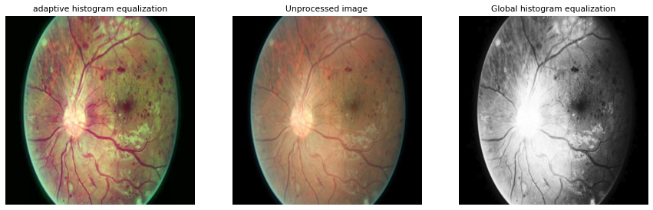

# Modeling

I chose Logistic Regression, Support Vector Machine and CNN models to Train on Detection Diabetic Retinopathy. I faced two main challenges the first challenge: my local Machine Memory was not big enough to handle all the data at once specially for the machine learning models (Logistic regression and SVM), second challenge was the huge imbalance in my data. The first Challenge, I was able to resolve by taking the global histogram equalization preprocessed images, as the features were third the RGB enhanced images, plus I took a 10% sample of the data. The second Challenge, I trained each model on the original unbalanced classes, then I oversampled and trained the models on balanced classes, at the end I trained the models on Binary Class where it was Negative DR and Positive DR. In this Report I will discuss my findings for every model.

# Logistic Regression & SVM

Before training any of the models I scaled the data and transformed the features using a minmax scaler and performed Feature engineering to reduce the number of dimensions while keeping 99.9% of the information.

The Models has tested poorly on all 3 trained data. For the unbalanced classes it predicted 85% of the Images to be Negative for Diabetes but still scored 65% accuracy, that is due to the huge imbalance of the classes. The case was different When I trained the model on Balanced Data, the model was able to predict the classes more accurately in comparison to the unbalanced class trained model. For the Binary classification, Logistic regression performed the best out of the 3, it scored 66% with around 70% recall that means less patients had false negatives but still not satisfactory. SVM on the other hand, performed slightly better on the Balanced and Unbalanced class data but failed to predict anything other than Negative for the Binary class.

The Confusion matrix Below is for the Logistic regression as it is the best

|  |  |  |
| --- | --- | --- |
| SAMPLE TYPE | LOGESTIC REGRESSION | SUPPORT VECTOR MACHINE |
| UNBALANCED | 65% | 70% |
| BALANCED | 29% | 32% |
| BINARY | 66% | 73% |

# Neural Networks

For Neural Networks I used the Adaptive Contrast equalization as I was able to feed the model my Images in small batches. I trained a shallow convolutional neural network on the unbalanced classes; the Neural network was unable to predict anything as it stopped after 3 epochs. For the balanced classes dataset, I had to first make sure that my duplicated Images were unique by performing multiple random augmentation methods (rotation, zoom, sheer, flipping, blurring). This allowed me to Duplicate Images from the minority classes but train them as if they’re completely new unique images. I then ran 2 Transfer learning models (RESNET50V2) and (DENSENET) both of which has performed much better than the shallow CNN, but the accuracy wasn’t that impressive. ResNet scored 55% and DenseNet 20%, the reason for the low results is, both models would mistake the negative DR class with the Mild DR that was because I Up sampled the classes of the training Data, while the test data was in the original Unbalance state, the solution would be a data that isn’t as unbalanced as the original or as the equally balanced one.

My focus was to prevent false positives as in Medicine It is very critical not to diagnose patients as healthy when they’re not. Resnet Had an 84% Recall accuracy meaning.

In the confusion Matrix Below is the results of Resnet50 model when trained on a binary classification. The results are promising as the accuracy was 74% and the recall was

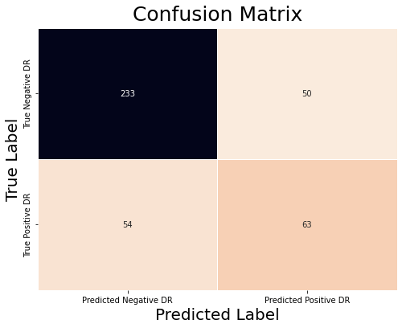

# Conclusion

None of My models had a very high accuracy results I was able to reduce the recall significantly. I believe that with more time to test different preprocessing techniques I’d be able to improve all the models as I found it is essential for the models’ performance. With faster computing power I’d be able to test neural network faster which would allow me to perform more tweaks and customizations.

REFERENCES

1 <https://www.ripublication.com/irph/ijert_spl17/ijertv10n1spl_96.pdf>

2 https://scikitimage.org/docs/0.19.x/auto_examples/color_exposure/plot_local_equalize.html

3 <https://www.mayoclinic.org/diseases-conditions/diabetic-retinopathy/symptoms-causes/syc-20371611#:~:text=The%20abnormal%20blood%20vessels%20associated%20with%20diabetic%20retinopathy,vision%2C%20flashes%20of%20light%20or%20severe%20vision%20loss>.

4 https://www.digitaldiagnostics.com/products/eye-disease/idx-dr/